CodeSys needs List for Trade Show Demos

1. HMI display for the LionX port and diagnostic status. The LED status should match/mimic the actual LEDs on the module (to the extent practical).

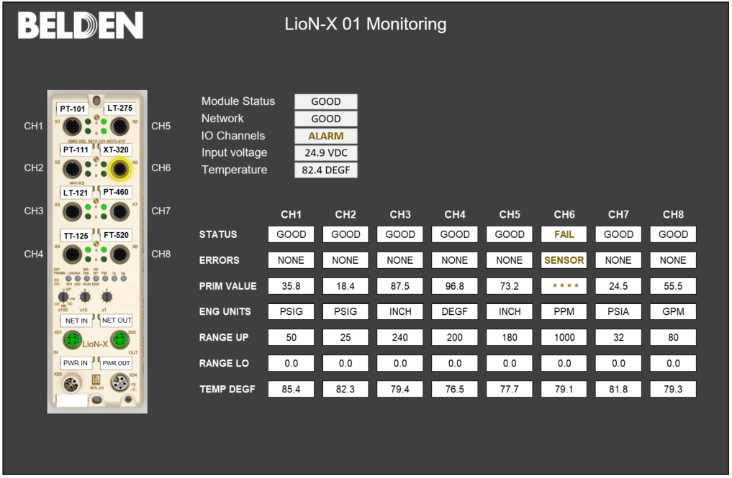

1. IO Link power supply status. The LED status should match/mimic the actual LEDs on the module (to the extent practical).

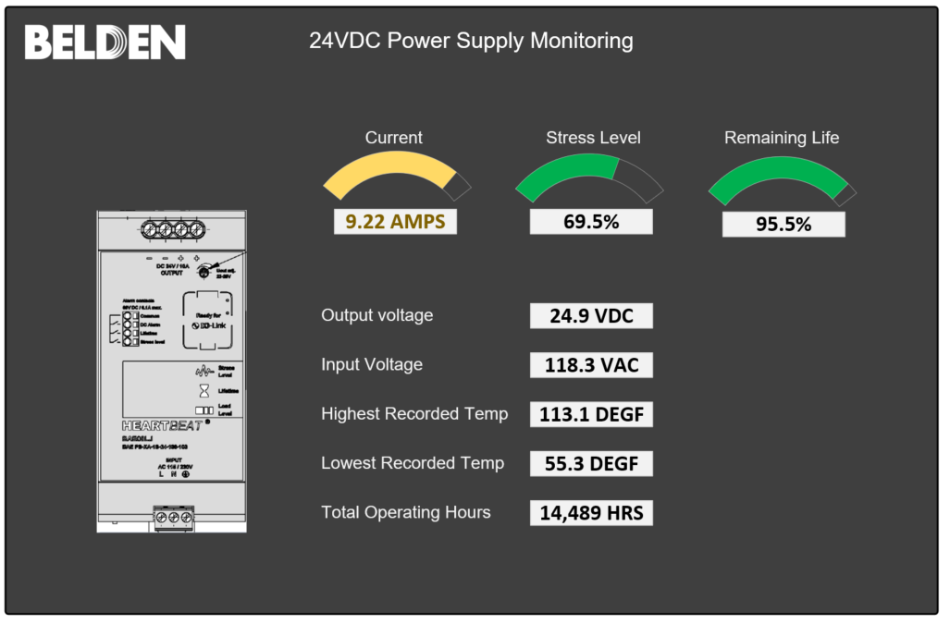

1. DC Electronic Circuit Breaker (ECB) power distribution block status. This is one just for Ray since it’s the newest and hardest. The Wago ECB used has the ability to monitor each of the 8 output channels (OFF, ON, TRIPPED) and the ability to remotely reset them using a pulse signal methodology. The CodeSys library elements to enable this are available from Wago.

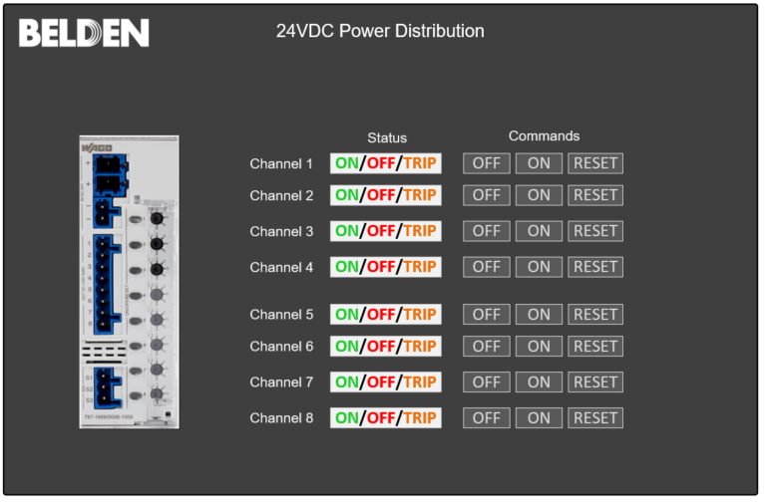

1. A process graphic display showing the data from several IO link sensors and touch-control for three (3) 240V fans that we’ll Start/Stop via starters and a LionX field IO block.